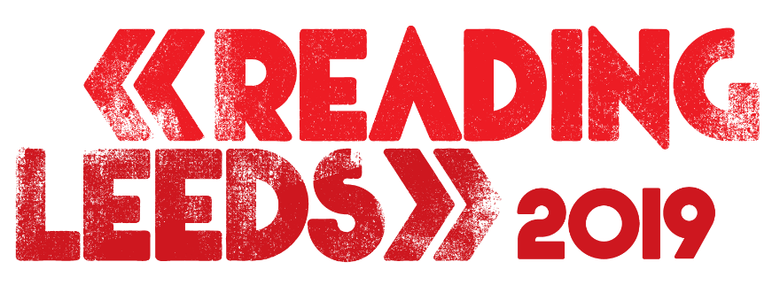 **OVER 70 ACTS ADDED!**

**DAVE, KING PRINCESS, DILLON FRANCIS, MACHINE GUN KELLY, RODDY RICCH,**

PLUS MANY MORE

JOIN HEADLINERS **THE 1975, POST MALONE, TWENTY ONE PILOTS** AND **FOO FIGHTERS**

**Æ MAK | AITCH | ANTEROS | ANTI UP | BAD CHILD**

**BAKAR | BASEMENT | BELAKO | BLACK HONEY**

**BLADE BROWN | BLOOD YOUTH | BOSTON MANOR | BRUNSWICK**

**CEMETERY SUN | CLAIRO | COUNTERFEIT. | DANILEIGH | DAPPY**

**DAVE | DENO DRIZ | DILLON FRANCIS | DIMENSION | DJ TARGET DREAM STATE | DREAMERS | EVERYONE YOU KNOW | THE FAIM FIDLAR | GEORGIA | GHOSTEMANE | HIGHER POWER**

**HIMALAYAS | HOBO JOHNSON & THE LOVEMAKERS | HOT MILK**

**JAGUAR SKILLS | JAMES ORGAN | JEREMY ZUCKER | JUST BANCO**

**K-TRAP | KENNY ALLSTAR | KING PRINCESS | LOSKI   
MACHINE GUN KELLY | MALEEK BERRY | MASICKA   
MAYDAY PARADE | MELLA DEE | MILK TEETH | MINI MANSIONS MOONTOWER | MTRNICA | MUZZY | NIGHT RIOTS | OCEAN ALLEY  
 OF MICE & MEN | PARIS | PATENT PENDING | PIP BLOM  
PRESS CLUB | PROSPA | PUP | PUPPY | RODDY RICCH | SAINT JHN SEA GIRLS | SMOKEASAC | THE SNUTS | SOPHIE AND THE GIANTS SPORTS TEAM | STAND ATLANTIC | SWMRS | TEDDY   
TIFFANY CALVER | TION WAYNE | TOMMY GENESIS | TRUEMENDOUS VALERAS | WHITE REAPER | ZUZU**

[**www.readingandleedsfestival.com**](http://www.readingandleedsfestival.com/)

Thursday 7th March 2019: **Reading & Leeds** **Festival** has today added over seventy more acts to the bill for this year’s event including **Dave, King Princess, Dillon Francis, Machine Gun Kelly,** and **Roddy Ricch**. They’ll be performing alongside already announced headliners **The 1975**, **Post Malone**, **Twenty One Pilots** and **Foo Fighters** at the famous Richfield Avenue and Bramham Park sites this August bank holiday weekend (23 – 25 August). Tickets are available [here](https://www.readingandleedsfestival.com/).

On the cusp of world domination, London-born rapper **Dave** will be headlining the **BBC** **Radio One Stage**.  As one of themost promising talents to emerge on the UK rap scene in recent years, Dave will be captivating festival goers with tracks from his forthcoming highly anticipated debut album ‘Psychodrama’ - due for release 8 March.  Along with amassing over 600m streams, Dave is the youngest ever winner of an Ivor Novello award, and has performed several major collaborations, including with fellow Londoner (and festival performer) AJ Tracey, and worldwide superstar Drake.

**Counterfeit.,** fronted by Jamie Campbell Bower,will be making a triumphant return to Reading & Leeds this summer on the **Main Stage** bill for a high-octane set that is sure to be full of punk rock anthems. Also added to the Main Stage for 2019 are emo powerhouse **Mayday Parade**,and Gloucestershire pop punk trio **Milk Teeth** who’ve cemented themselves as one of the brightest stars in the scene**.**

Cleveland, Ohio rapper **Machine Gun Kelly** will be storming the **BBC** **Radio One Stage** playing hits such as *Rap Devil* and *Bad Things*, continuing an already successful 2019 that has also seen the multi talented artist starring in Netflix’s Motley Crue biopic ‘The Dirt’, as infamous drummer Tommy Lee.  After being nominated for BBC Sound of 2019, **Sea Girls**’refreshing guitar pop sound is crafted into non-stop bangers, destined to be yelled – hands in the air, eyes shut. Also joining the BBC Radio One stage are ambitious Australian rockers **The Faim,**  American singer **Clairo,** who has attracted over 26 million views on YouTube for her song *Pretty Girl*, US Indie pop songstress Mikaela Straus- aka **King Princess**, and Compton’s **Roddy Ricch**, whose hybrid trap has seen the MC become a rising star.

One of the hottest acts in electronic music today, American platinum-selling producer and DJ **Dillon Francis** will bring his blend of uplifting melodies and potent dancefloor beats to the **BBC** **Radio One Dance Stage** this summer, with **Dimension** also delivering a captivating set of electronic ground-shakers. Joining them will be British craftsman and greatest mash-up DJ on the planet **Jaguar Skills**, returning to Reading & Leeds for a unforgettable set of sublime technical skills and an incredible stage show.

Headlining **The Pit Stage** is American Rapper **Ghostemane**. Famed for being an innovator of the fusion between rap and metal, Ghostemane marries raspy black metal textures with juddering industrial low-end and frantic hardcore howling. Artists joining The Pit Stage across the weekend also include metal-core heroes **Of Mice & Men**, Canadian Punk heavyweights **PUP**, hardcore punk band **Blood Youth**, **Hot Milk** who have exploded onto the scene with debut single *Awful Ever After*, and **Fidlar** who have recently released their third album ‘Almost Free’.

American viral internet sensation, **Hobo Johnson** **& The Lovemakers** will headline the **Festival Republic Stage** marking his Reading & Leeds debut. Darlings of the British rock underground-turned-next-big-thing, **Basement** will bring their tour de force of anthemic Anglo-American rock to the Festival Republic Stage, along with English dream pop band **Anteros,** fronted by Laura Hayden.

Headlining the **BBC** **1Xtra Stage** will be the one and only **Dappy**. After recently releasing brand new solo music and collaborating with the hottest world class talent including Yungen, he is sure to be a highlight of the weekend.  Also joining the BBC 1Xtra line-up is South London rapper **Loski** who is making major waves within the hip-hop scene, and grime star **Tion Wayne.**

**Æ MAK, Aitch, Anti Up, Bad Child, Bakar, Belako, Black Honey, Blade Brown, Boston Manor, Brunswick, Cemetery Sun, DaniLeigh, Deno Driz, DJ Target, Dream State, Dreamers, Everyone You Know, Georgia, Higher Power, Himalayas, James Organ, Jeremy Zucker, Just Banco, K-Trap, Kenny Allstar, Maleek Berry, Masicka, Mella Dee, Mini Mansions, Moontower, MTRNICA, Muzzy, Night Riots, Ocean Alley, Paris, Patent Pending, Pip Blom, Press Club, Prospa, Puppy, SAINt JHN, Smokeasac, The Snuts, Sophie and the Giants, Sports Team, Stand Atlantic, SWMRS, Teddy, Tiffany Calver, Tommy Genesis, TrueMendous, VALERAS, White Reaper, and Zuzu** have also been added to the stellar bill already confirmed for Reading & Leeds 2019.

**Æ MAK** and **TrueMendous** come to Reading & Leeds Festival as part of Festival Republic and PRS Foundation’s ReBalance programme, a pioneering scheme launched in 2017 that has seen hundreds of nominations across 4 rounds, resulting in 13 finalists, and offers support, studio time, and festival slots.

With hundreds of acts set to play, Reading & Leeds will again be the unmissable festival weekend of the summer - defining and celebrating the sounds of modern groundbreaking music, as well as a world-class comedy line up.

Fans can be the first to hear further line-up announcements, artist news and much more by signing up to the newsletters at [www.readingfestival.com](http://www.readingfestival.com/) and [www.leedsfestival.com](http://www.leedsfestival.com/) or via the official **Reading & Leeds Festival app**, available to download now on Android and iOS.

**TICKET INFORMATION**

**General tickets on sale from** [**www.readingandleedsfestival.com**](http://www.readingandleedsfestival.com/)

**MEDIA CONTACTS:**

**Reading Festival**

Libby Maguire [libby.maguire@ldcommunications.co.uk](mailto:libby.maguire@ldcommunications.co.uk)

Sarah Wareing [sarah.wareing@ldcommuncations.co.uk](mailto:sarah.wareing@ldcommuncations.co.uk)

**Leeds Festival**

David Cox [david.cox@ldcommunications.co.uk](mailto:david.cox@ldcommunications.co.uk)

**Sign up here for** [**Reading**](http://www.readingfestival.com/subscribe) **and** [**Leeds**](http://www.leedsfestival.com/subscribe) **newsletters.**

**FESTIVAL PARTNERS**



Carlsberg are proud to be the official beer partner of Reading and Leeds Festival. Carlsberg will be bringing a touch of Danishness to the festival this summer as it’s the fusion of Danish simplicity and precision that brings you a light, easy drinking, refreshing lager.

[www.carlsberg.co.uk](http://www.carlsberg.co.uk)



Somersby are excited to be the official cider partner of Reading and Leeds Festival. Best served thirsty. This delicious cold-filtered cider has no artificial flavours or sweeteners, simply bucket-loads of great apple taste. That’s real refreshment.

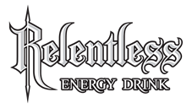

For over a decade, **Relentless Energy Drink** have staked their claim at Reading & Leeds festival. We will be returning once again in 2019 as the Official Energy Drink Partner.

While the party returns this year with the legendary Relentless Stage at Leeds, we’ll also be keeping the ravers energised over at Reading too.

Visit us at [www.relentlessenergy.com](http://www.relentlessenergy.com/)

[www.facebook.com/RelentlessEnergy](http://www.facebook.com/RelentlessEnergy)

[www.twitter.com/relentlessdrink](http://www.twitter.com/relentlessdrink) to join the conversation.



MIX IT UP WITH SMIRNOFF AT READING & LEEDS THIS SUMMER!

To celebrate this year’s epic festival season, Smirnoff, the world’s most popular vodka brand, is proud to be the official vodka and partner with the biggest festivals across Europe including Reading & Leeds; teaming up with great music and the incredible Smirnoff Soda Fruit Smash drink this year, be sure not to miss out!

Follow us on Instagram @SmirnoffEurope or on Facebook [facebook.com/smirnoffGB](http://facebook.com/smirnoffGB), for all of the latest festival news and gossip from around Europe and some exciting ways to get involved this summer! [http://www.smirnoff.com/](https://clicktime.symantec.com/a/1/Wza5Q0jEf95l-F7wDbNK-gc96RIU0Zia7aVT6X-PQVk=?d=KXXFTcQrBthQggXSm_5uLR5ozDz70xJHm5V2Vai7fiLXv7x1x142v_MA5IXsnZZNGIUDJ-J6IBtcPW0xDSrRuTMjEzu8Oe3OAV96kXkNs_aeoDM05q69C_gcX7A8I-oVn3gPpD2SeZ02PQaT-OlkxqJfNHuHqg1mMtWVKVEkLvGWeeWukU540KdFeSNzxTi9N3I5eU--k1Qn5KtZTfj3HMyc9fMKYG5OxbQM2yJ4hE1rzdnL9Lc7Xa3tJN05SpQvllv5GrvKZePxGz0Pce4nHZ_CPZ8c1B4ybJ41ZRkwi4TaEtSUY4lRmgvVx6fiybWY2fx_hpW1MhjJr_2WRbC5w_ygTfHI6q7lYV8b9SrJ9LB30es_CClTdJgNALCU5lxvRrgEwc8tfy6RSu8s-T_H6_Y%3D&u=http%3A%2F%2Fwww.smirnoff.com%2F)

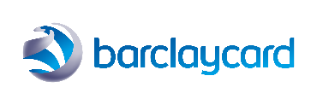

Barclaycard – official payment partner of Reading & Leeds Festival.

With Barclaycard Entertainment you will always get more – Jump the queue for 2019 presale tickets, plus get 10% back at the checkout for each presale ticket* you buy through Barclaycard Entertainment.  Plus pay for Food & Drink* on site with your Barclaycard and get 5% off. T&Cs apply.

Find out more: [www.barclaycard.co.uk/entertainment](http://www.barclaycard.co.uk/entertainment)

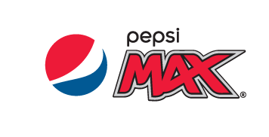

As an official sponsor of some of the greatest UK festivals, Pepsi MAX takes a bold approach to bringing people together through music. Pepsi MAX are a long-standing partner of Live Nation and look forward to creating more musical moments together. Pepsi MAX offers the full Pepsi taste with no sugar**.**



Good things happen when people can move, whether across town or towards their dreams. Opportunities appear, open up, become reality. What started as a way to tap a button to get a ride has led to billions of moments of human connection as people around the world go all kinds of places in all kinds of ways with the help of our technology. Find out more at [www.uber.com](http://www.uber.com).