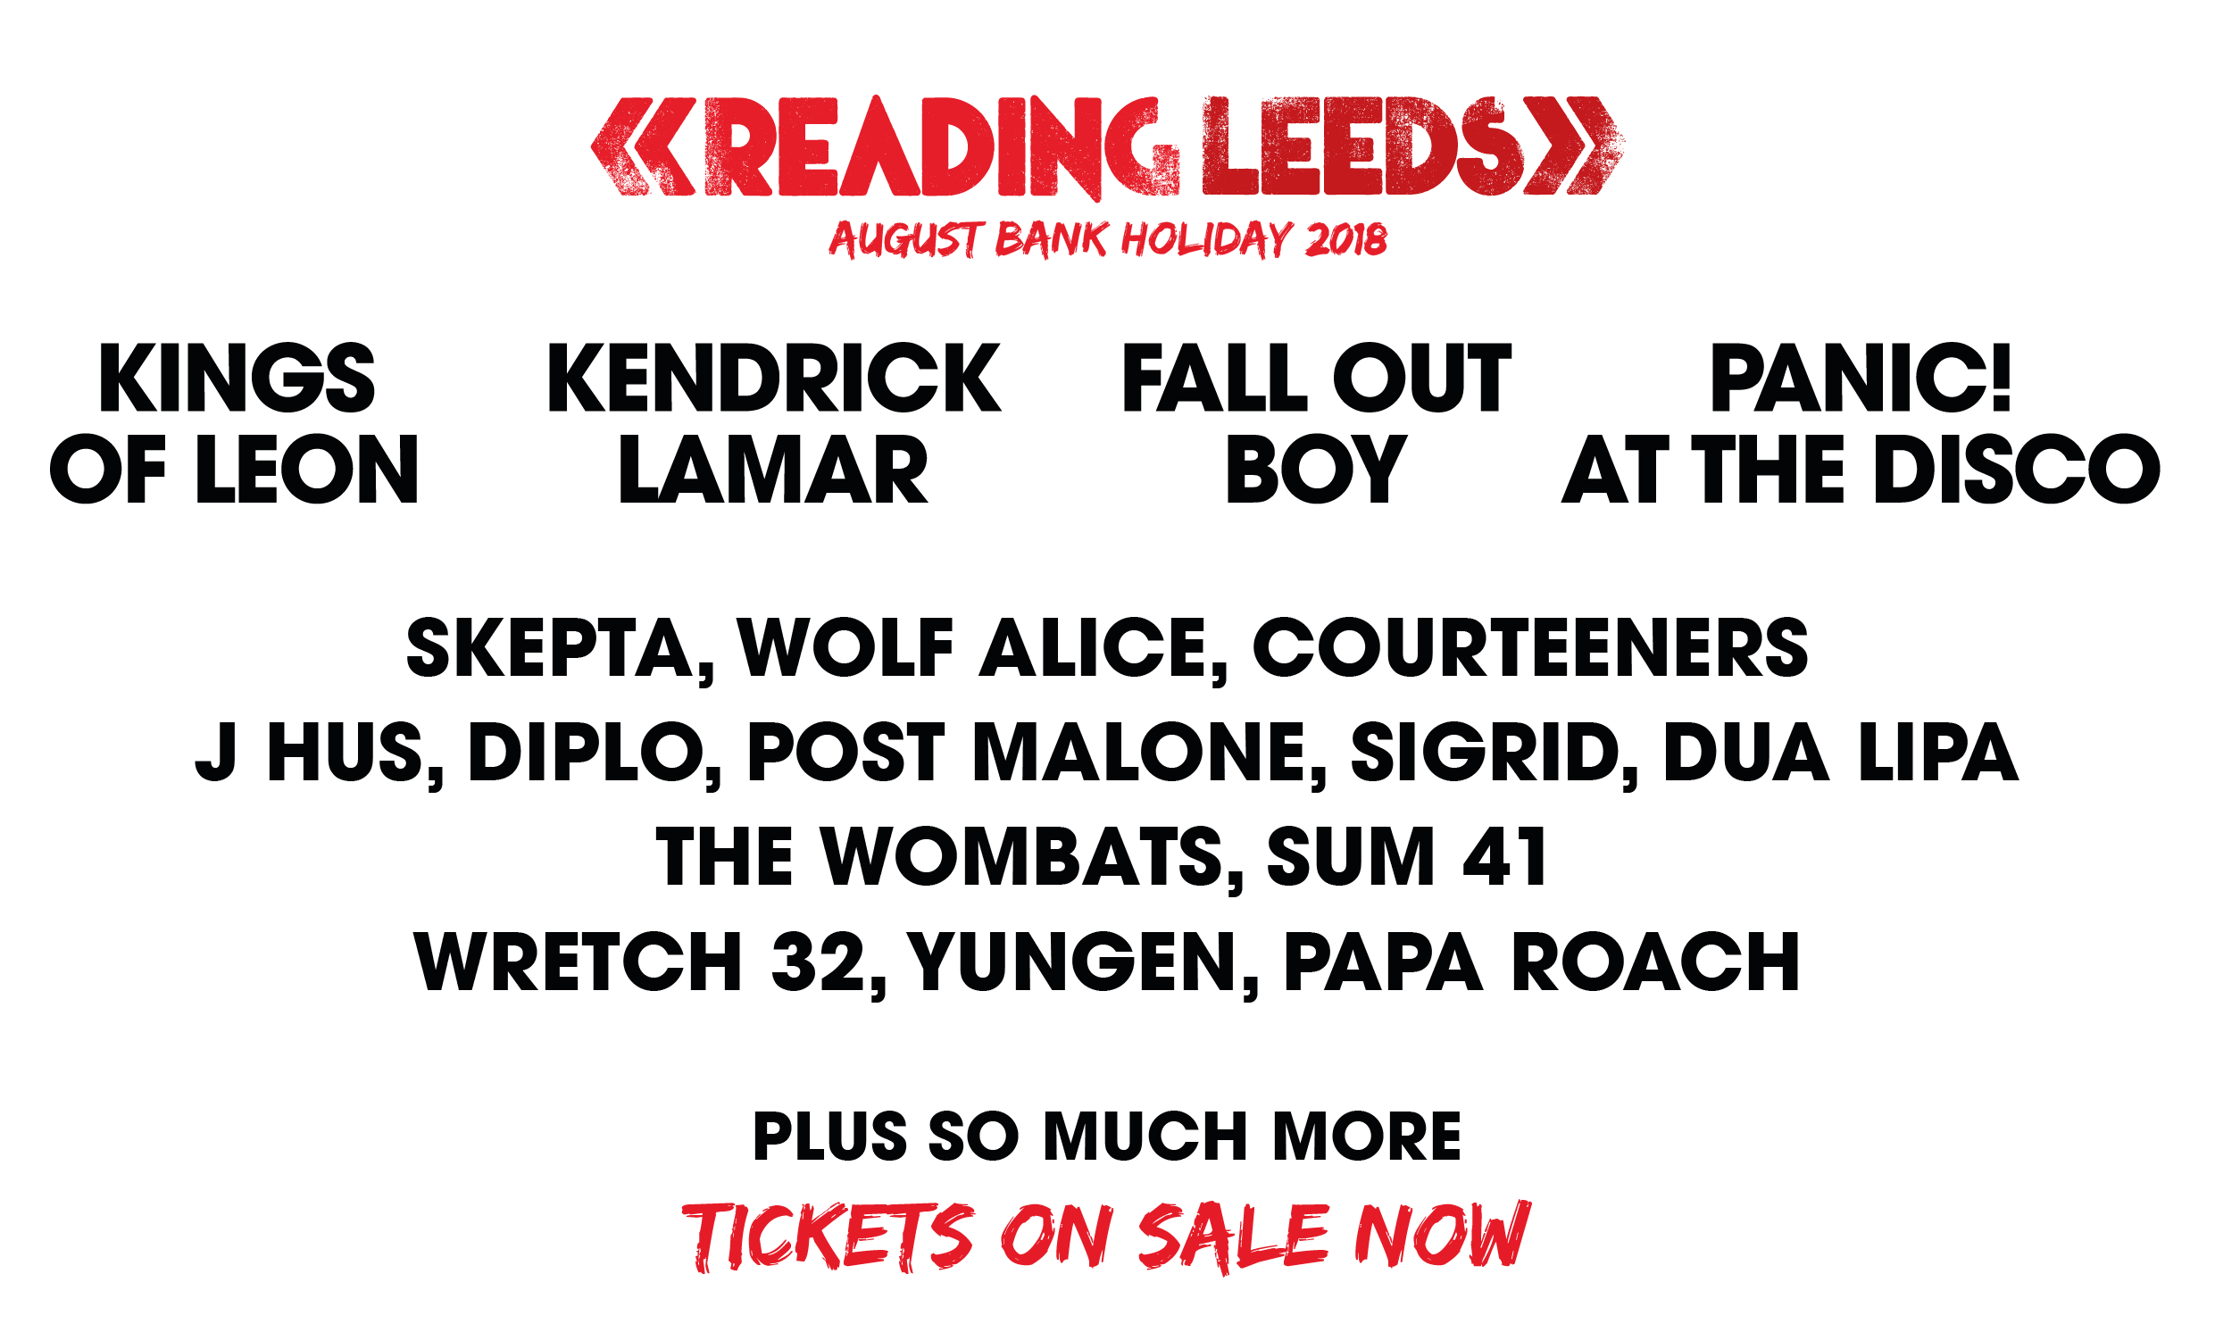

Tuesday, 13 February 2018: **Reading and Leeds Festival** has revealed **Kendrick Lamar, Kings of Leon, Fall Out Boy,** and **Panic! at the Disco** as its 2018 headliners – and just four of **54** **names** announced to play at Reading’s famous **Richfield Avenue** and Leeds’ legendary **Bramham Park** this August bank holiday weekend (24th – 26th). **Skepta**, **Wolf Alice**, **Annie Mac, Dua Lipa, J Hus, Diplo, Ms Banks, Pale Waves, Sigrid, Wretch 32** and **Yungen** are amongst the top rock, dance, alternative and urban acts on the line-up. Tickets are on sale now and available [here](https://www.readingandleedsfestival.com/).

**Kings of Leon** headline Reading and Leeds for their second time. With seven albums under their belt and an arsenal of hits –there are few better equipped to close a day of top music at Reading and Leeds.

Probably the hottest act in the world right now and in the middle of a sold-out stint of UK shows, **Kendrick Lamar** returns to Reading and Leeds this year– and rightly so, being the new owner of five Grammy Awards. The Compton rapper is expected to deliver an unstoppable set on the Reading and Leeds stages, packed with trailblazing hits from widely acclaimed 2017 album *DAMN.*

**Fall Out Boy**are also revealed as Richfield Avenue and Bramham Park headliners. True Reading and Leeds veterans and crowd favorites, the Chicago four-piece has established their place on the festival bill over the last decade. This time around, fans can expect a guitar-fuelled celebration of certified hits like “*Dance, Dance,”* "*Thnks fr th Mmrs,” “Centuries”*as well as new songs from their latest album *MANIA*.

Completing the quartet of headliners this year are **Panic! at the Disco**. Brendon Urie and his Las Vegas outfit will take the crowds through a night-time journey of a glittering back catalogue – including landmark albums *Pretty. Odd* and *A Fever You Can’t Sweat Out*, along with songs from the certified platinum, Grammy nominated album *Death Of A Bachelor.*

Elsewhere, the record-breaking **Dua Lipa** will play Reading and Leeds as a UK festival exclusive this summer, joined by the hotly-tipped new acts **Sigrid** and **Pale Waves**. Dance fans will have their fill with the likes of legends such as **Annie Mac,** Birmingham breakthrough DJ favourite **Hannah Wants, Riton & Kah-Lo,** Bristolian duo **My Nu Leng** and American genius and Major Lazer co-creator **Diplo**.

Flying the flag for UK urban music this year is luminary **Skepta** who will take to the stage following his surprise appearance with Lethal Bizzle in 2017, as well as triple BRIT Award-nominee **J Hus**, **AJ Tracey**, **Ms Banks**, **IAMDBB, Wretch 32**, **Nadia Rose**, **Kojo Funds** and **Fredo**. Stateside stars joining the bill are **Playboi Carti**, **Lil Pump** and modern hip-hops self-proclaimed boyband **Brockhampton**, as well as the genre-defying **Post Malone** - the 22-year old NYC musician making musical waves around the world.

Following a secret opening performance on the Festival Republic stage last year, Reading and Leeds favourite **Wolf Alice** are set to play. The North London quartet’s 2017 album ‘Visions of a Life’ received widespread critical acclaim, with NME calling it the album of the year and affirming them as ‘Best Band in Britain’ – so we can no doubt expect an even more exhilarating set this year.

Indie fans will not be disappointed, with some of the most genre-defining acts billed to play this year. Liverpool rockers **The Wombats** join the line up, following their recently released album ‘Beautiful People Will Ruin Your Life’. Repping Manchester will be **Courteeners,** storming through five studio albums and hits including ‘Not Nineteen Forever’ and ‘What Took You So Long’. Brighton four-piece **The Magic Gang** also join the bill in addition to Bedford-born and critically celebrated singer-songwriter **Tom Grennan** takes to the stage beside them after an incredible first year.

Reading and Leeds have been famous for earth-shattering rock acts over the years and 2018 will be no different, with something on the line-up for every type of rock fan. Florida rock outfit **UnderØath** will appear this year alongside the likes of noughties favourites **Sum 41** and none other than California legends **Papa Roach**, as well as **Waterparks**, **Hollywood Undead** and Ohio-based hardcore band **Beartooth**. The best in British rock will of course also be represented in the form of **Creeper –** Southampton’s famous horror-punk six-piece.

A full working line-up, with many more to be added, is available below.

Festival Republic’s **Melvin Benn** commented: *“Reading and Leeds prides itself on being a music-first festival and this year’s line-up already proves that. Kings of Leon and Fall Out Boy are bands that have grown with the festival and its fans and we couldn’t be more pleased to invite them back to headline. Adding Panic! at the Disco and Kendrick Lamar, probably the most sought-after act in the world right now, we think Reading and Leeds Festivals 2018 are off to an amazing start – with even more to come, so watch this space.”*

With hundreds of acts set to play, Reading and Leeds will again be the unmissable festival weekend of the summer - defining and celebrating the sounds of modern ground-breaking music, as well as a world-class comedy line up.

Fans can be the first to hear further line-up announcements, artist news and much more by signing up to the newsletters at [www.readingfestival.co.uk](http://www.readingfestival.co.uk) and [www.leedsfestival.co.uk](http://www.leedsfestival.co.uk) or via the official **Reading and Leeds Festival app**, available to download now on Android and iOS.

**READING AND LEEDS 2018 – THE LINE-UP SO FAR**

Kendrick Lamar

Kings Of Leon

Fall Out Boy

Panic! at the Disco

$uicide Boy$

A Boogie Wit Da Hoodie

AJ Tracey

Annie Mac

Beartooth

Belly

Bicep Live

Brockhampton

Courteeners

Creeper

Diplo

Dream Wife

Dua Lipa

Fredo

Ghetts

Hannah Wants

Hinds

Hollywood Undead

Hudson Taylor

IAMDDB

J Hus

Kojo Funds

Lil Pump

Mist

Mr EAZI

Ms Banks

My Nu Leng

Nadia Rose

Netsky b2b Jauz b2b Slushii

nothing,nowhere

Nothing But Thieves

Pale Waves

Papa Roach

Playboi Carti

Post Malone

Riton & Kah-Lo

Sigrid

Skepta

Ski Mask The Slump God

Sum 41

The Blaze

The Magician

The Magic Gang

The Wombats

Tom Grennan

UnderØath

Waterparks

Wolf Alice

Wretch 32

Yungen

Plus many more to be announced

**TICKET INFORMATION**

**Tickets are on sale now from** [**www.readingandleedsfestival.com**](http://www.readingandleeds.co.uk)

**MEDIA CONTACTS:**

**Reading Festival**

Sam Roberts

[Sam.roberts@ldcommunications.co.uk](mailto:Sam.roberts@ldcommunications.co.uk)

**Leeds Festival**

David Cox

[david.cox@ldcommunications.co.uk](mailto:david.cox@ldcommunications.co.uk)

**Sign up here for** [**Reading**](http://www.readingfestival.com/subscribe) **and** [**Leeds**](http://www.leedsfestival.com/subscribe) **newsletters.**

**Partners**



Carlsberg are proud to be the official beer partner of Reading and Leeds Festival. Carlsberg will be bringing a touch of Danishness to the festival this summer as it’s the fusion of Danish simplicity and precision that brings you a light, easy drinking, refreshing lager.

<http://www.carlsberg.co.uk>



Somersby are excited to be the official cider partner of Reading and Leeds Festival. Best served thirsty. This delicious cold-filtered cider has no artificial flavours or sweeteners, simply bucket-loads of great apple taste. That’s real refreshment.

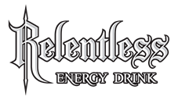

For over a decade, **Relentless Energy Drink** have staked their claim at Reading & Leeds festival. We will be returning once again in 2018 as the Official Energy Drink Partner.

While the party returns this year with the legendary Relentless Stage at Leeds, we’ll also be keeping the ravers energised over at Reading too.

Visit us at [www.relentlessenergy.com](http://www.relentlessenergy.com/)

[www.facebook.com/RelentlessEnergy](http://www.facebook.com/RelentlessEnergy)

[www.twitter.com/relentlessdrink](http://www.twitter.com/relentlessdrink) to join the conversation.



MIX IT UP WITH SMIRNOFF AT READING & LEEDS FESTIVAL THIS SUMMER!

To celebrate this year’s epic festival season, Smirnoff, the world’s most popular vodka brand, is proud to be the official vodka and partner with the biggest festivals across Europe including Reading & Leeds; teaming up with great music and the incredible Smirnoff Soda & Fruit Smash drink this year, be sure not to miss out!

Follow us on Instagram @SmirnoffEurope or on Facebook facebook.com/smirnoffGB, for all of the latest festival news and gossip from around Europe and some exciting ways to get involved this summer! <http://www.smirnoff.com/>

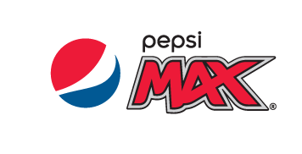

As an official sponsor of some of the greatest UK festivals, Pepsi Max takes a bold approach to bringing people together through music. Pepsi Max are a long-standing partner of Live Nation and look forward to creating more musical moments together. Pepsi Max offers the full Pepsi taste with no sugar.

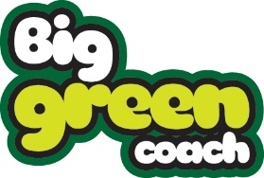

Reading & Leeds Festival are proud to once again name Big Green Coach as the Official Coach Travel Provider again this year. Big Green Coach are the UK’s largest travel events company and will be providing coach services for weekend campers, alongside day return services.

They will be offering the chance to buy low cost return coach services, with or without your festival ticket as a package. Festival goers can choose to arrive on Wednesday, Thursday or Friday and Big Green Coach will get all campers home on Monday.

Day services are timed to arrive before music starts and will not depart until music finishes.

With 80 pick-up points are available across the UK, prices start from just £35 return.